Types of movies
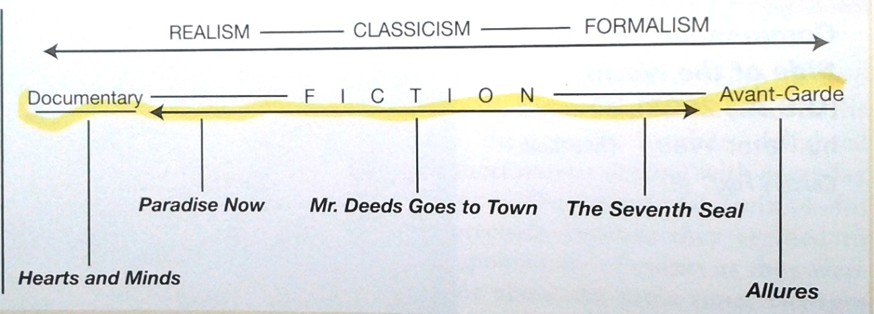

Realism classicism formalism
Documentary typical fiction movie avant-garde
More concerned with hand of the author is clear authorial
Content rather than form not obvious intervention
Or technique

Most movies are filmed at 24 frames per second (fps). Shooting at a higher rate (overcranking), while projecting at 24 fps gives slow motion (slo mo). Shooting at a lower rate (undercranking) while projecting at 24 fps, gives fast motion.
The opening in front of the camera where the lens fits is called the aperature.
Describing Shots
When describing camera angles, or creating them yourself, you have to think about three important factors
- Types of camera movements
- Types of camera framing
- Types of camera angles

- Types of camera movements
A director may choose to move action along by telling the story as a series of cuts, going from one shot to another, or they may decide to move the camera with the action. Moving the camera often takes a great deal of time, and makes the action seem slower, as it takes several second for a moving camera shot to be effective, when the same information may be placed on screen in a series of fast cuts. Not only must the style of movement be chosen, but the method of actually moving the camera must be selected too. There are seven basic methods:
- Pans - A movement which scans a scene horizontally. The camera is placed on a tripod, which operates as a stationary axis point as the camera is turned, often to follow a moving object which is kept in the middle of the frame.

- Tilts - A movement which scans a scene vertically, otherwise similar to a pan.

- Dolly Shots - Sometimes called TRUCKING or TRACKING shots. The camera is placed on a moving vehicle and moves alongside the action, generally following a moving figure or object. Complicated dolly shots will involve a track being laid on set for the camera to follow, hence the name. The camera might be mounted on a car, a plane, or even a shopping trolley (good method for independent film-makers looking to save a few dollars). A dolly shot may be a good way of portraying movement, the journey of a character for instance, or for moving from a long shot to a close-up, gradually focusing the audience on a particular object or character.

- Hand-held shots - The hand-held movie camera first saw widespread use during World War II, when news reporters took their windup Arriflexes and Eyemos into the heat of battle, producing some of the most arresting footage of the twentieth century. After the war, it took a while for commercially produced movies to catch up, and documentary makers led the way, demanding the production of smaller, lighter cameras that could be moved in and out of a scene with speed, producing a "fly-on-the-wall" effect. This aesthetic took a while to catch on with mainstream Hollywood, as it gives a jerky, ragged effect, totally at odds with the organized smoothness of a dolly shot. The Steadicam (a heavy contraption which is attached a camera to an operator by a harness. The camera is stabilized so it moves independently) was debuted in Marathon Man (1976), bringing a new smoothness to hand held camera movement and has been used to great effect in movies and TV shows ever since. No "walk and talk" sequence would be complete without one. Hand held cameras denote a certain kind of gritty realism, and they can make the audience feel as though they are part of a scene, rather than viewing it from a detached, frozen position.

- Crane Shots - Basically, dolly-shots-in-the-air. A crane (or jib), is a large, heavy piece of equipment, but is a useful way of moving a camera - it can move up, down, left, right, swooping in on action or moving diagonally out of it. The camera operator and camera are counter-balanced by a heavy weight, and trust their safety to a skilled crane/jib operator.

- Zoom Lenses - A zoom lens contains a mechanism that changes the magnification of an image. On a still camera, this means that the photographer can get a 'close up' shot while still being some distance from the subject. A video zoom lens can change the position of the audience, either very quickly (a smash zoom) or slowly, without moving the camera an inch, thus saving a lot of time and trouble. The drawbacks to zoom use include the fact that while a dolly shot involves a steady movement similar to the focusing change in the human eye, the zoom lens tends to be jerky (unless used very slowly) and to distort an image, making objects appear closer together than they really are. Zoom lenses are also drastically over-used by many directors (including those holding palmcorders), who try to give the impression of movement and excitement in a scene where it does not exist. Use with caution - and a tripod!

- The Aerial Shot - An exciting variation of a crane shot, usually taken from a helicopter. This is often used at the beginning of a film, in order to establish setting and movement. A helicopter is like a particularly flexible sort of crane - it can go anywhere, keep up with anything, move in and out of a scene, and convey real drama and exhilaration — so long as you don't need to get too close to your actors or use location sound with the shots.

- Types of shots
- Extreme long shot – also called establishing shots. People are dots on the screen. Almost always exteriors. This can be taken from as much as a quarter of a mile away, and is generally used as a scene-setting, establishing shot. It normally shows an EXTERIOR, for example the outside of a building, or a landscape, and is often used to show scenes of thrilling action in a war film or disaster movie. There will be very little detail visible in the shot, it's meant to give a general impression rather than specific information.
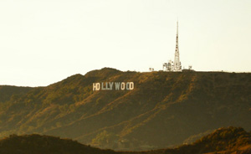

- Long shot – This is the most difficult to categorizes precisely, but is generally one which shows the image as approximately "life" size ie corresponding to the real distance between the audience and the screen in a cinema (the figure of a man would appear as six feet tall). It corresponds to what you would expect to see on a large stage in a theater.
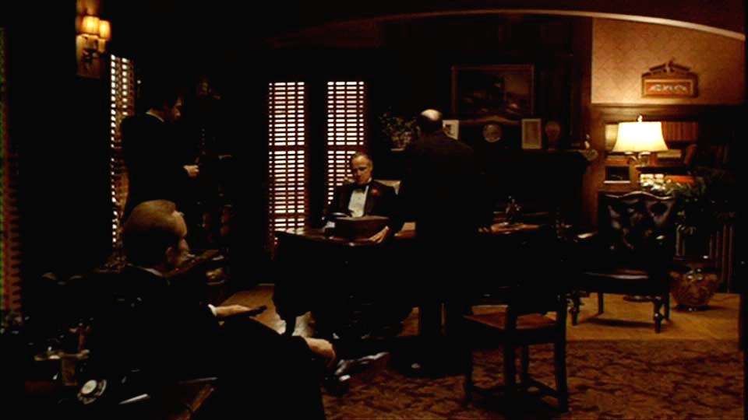
- Full shot – top of the head to the feet.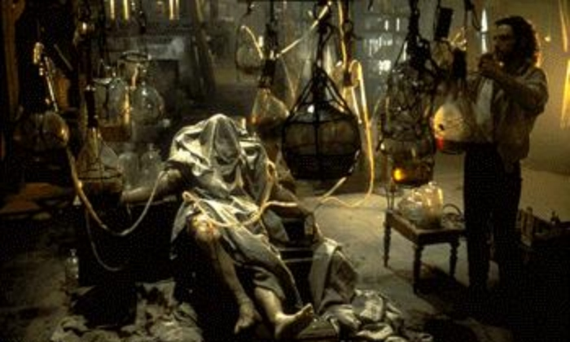

- Medium shot – Contains a figure from the knees/waist up and is normally used for dialogue scenes, or to show some detail of action. Variations on this include the TWO SHOT (containing two figures from the waist up) and the THREE SHOT (contains 3 figures). Any more than three figures and the shot tends to become a long shot. Background detail is minimal, probably because location has been established earlier in the scene - the audience already know where they are and now want to focus on dialogue and character interaction. Another variation in this category is the OVER-THE-SHOULDER-SHOT, which positions the camera behind one figure, revealing the other figure, and part of the first figure's back, head and shoulder. 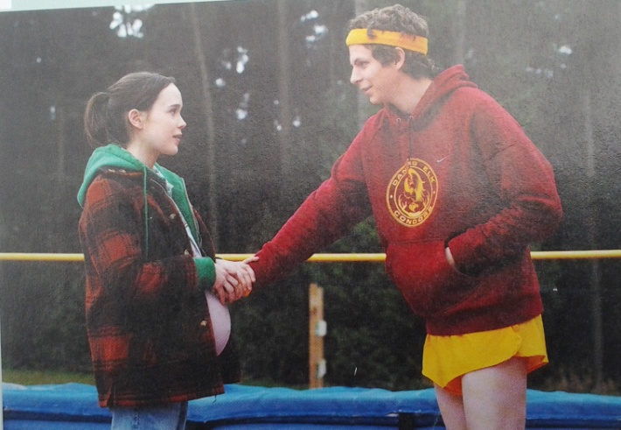

- Close up – This shows very little background, and concentrates on either a face, or a specific detail of mise en scène. Everything else is just a blur in the background. This shot magnifies the object (think of how big it looks on a cinema screen) and shows the importance of things, be it words written on paper, or the expression on someone's face. The close-up takes us into the mind of a character. In reality, we only let people that we really trust get THAT close to our face - mothers, children and lovers, usually - so a close up of a face is a very intimate shot. A film-maker may use this to make us feel extra comfortable or extremely uncomfortable about a character, and usually uses a zoom lens in order to get the required framing.
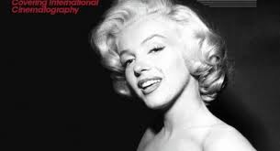

- Extreme close up – As its name suggests, an extreme version of the close up, generally magnifying beyond what the human eye would experience in reality. An extreme close-up of a face, for instance, would show only the mouth or eyes, with no background detail whatsoever. This is a very artificial shot, and can be used for dramatic effect. The tight focus required means that extra care must be taken when setting up and lighting the shot - the slightest camera shake or error in focal length is very noticeable.
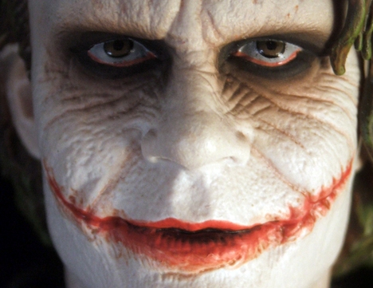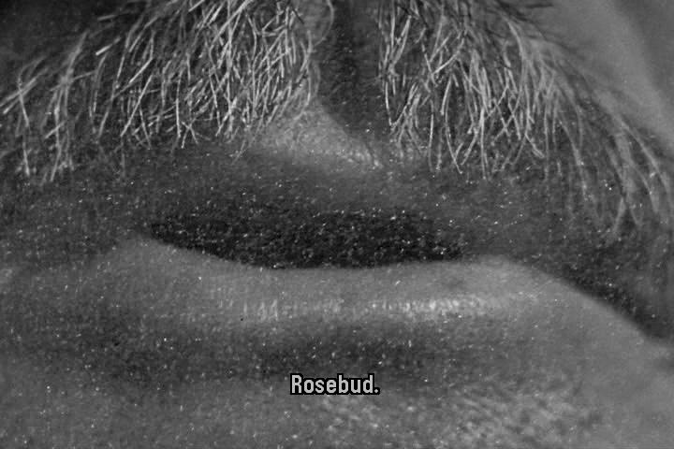

- Types of Camera angles
- Bird’s Eye View - This shows a scene from directly overhead, a very unnatural and strange angle. Familiar objects viewed from this angle might seem totally unrecognizable at first (umbrellas in a crowd, dancers' legs). This shot does, however, put the audience in a godlike position, looking down on the action. People can be made to look insignificant, ant-like, part of a wider scheme of things. Hitchcock (and his admirers, like Brian de Palma) is fond of this style of shot.
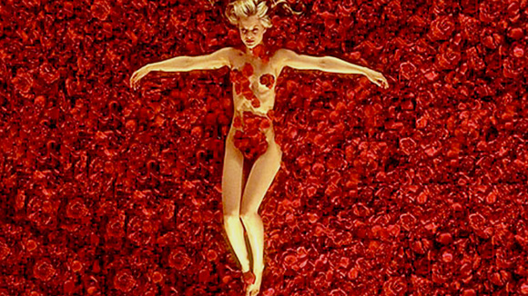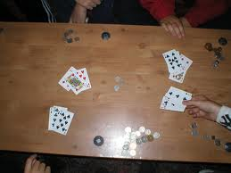

- High Angle Shot - Not so extreme as a bird's eye view. The camera is elevated above the action using a crane to give a general overview. High angles make the object photographed seem smaller, and less significant (or scary). The object or character often gets swallowed up by their setting - they become part of a wider picture.
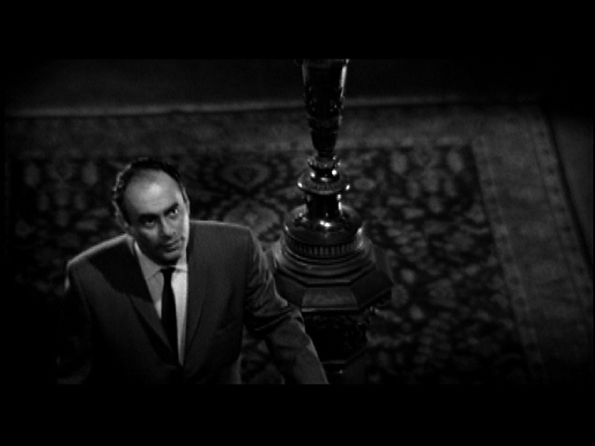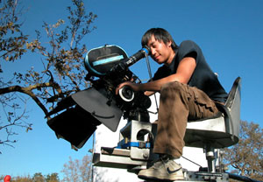

- Eye level shot - A fairly neutral shot; the camera is positioned as though it is a human actually observing a scene, so that the actors' heads are on a level with the camera. The camera will be placed approximately five to six feet from the ground. Below is an example of a medium 2 shot, filmed at eye level. The lighting style could be considered as high contrast.
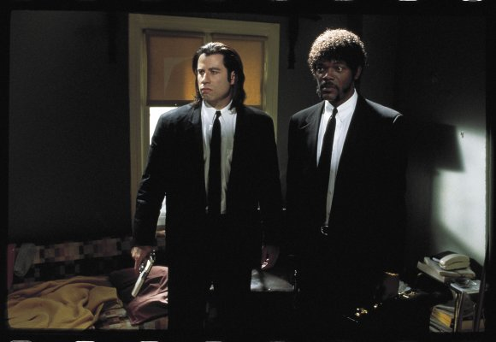

- Low angle – These increase height of actors and give a sense of speeded motion. Low angles help give a sense of confusion to a viewer, of powerlessness within the action of a scene. The background of a low angle shot will tend to be just sky or ceiling, the lack of detail about the setting adding to the disorientation of the viewer. The added height of the object may make it inspire fear and insecurity in the viewer, who is psychologically dominated by the figure on the screen.
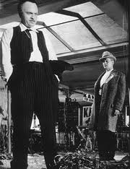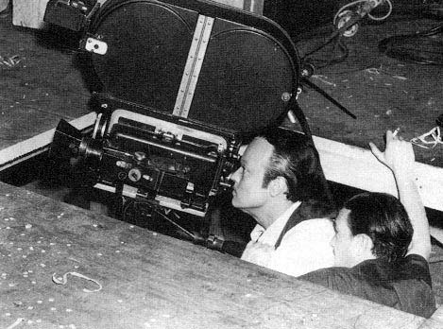

- Oblique angle (Dutch angle) - Sometimes the camera is tilted (ie is not placed horizontal to floor level), to suggest imbalance, transition and instability (very popular in horror movies). This technique is used to suggest POINT-OF-View shots (ie when the camera becomes the 'eyes' of one particular character, seeing what they see — a hand held camera is often used for this.
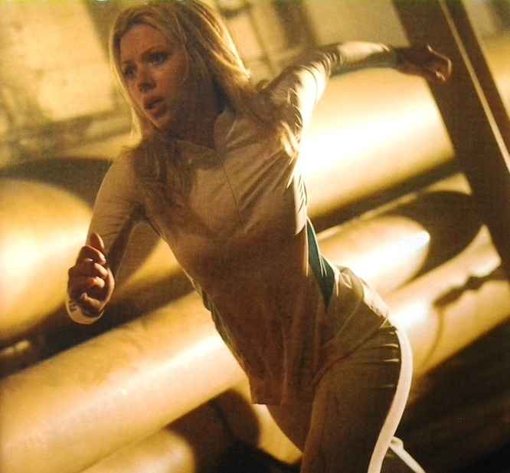

Lighting
Determined by cinematographer – also known as the director of photography (DP). Controls the lighting scheme, film stock, lenses and so forth. Responsible for the quality of the visual image.
Types of lighting:
- High key – often seen in romantic comedies and musicals, encompassing an even lighting pattern and avoiding dark areas in the frame. Everything looks bright with little to no shadow at all. High-key lighting has little dramatic effect, and it is often used in a scene with no tension.
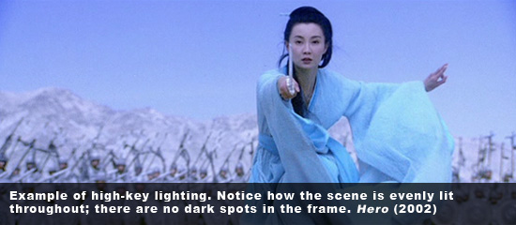

- High Contrast – exaggerated contrast in light and dark. Strong, heavy shadows, pools of light.
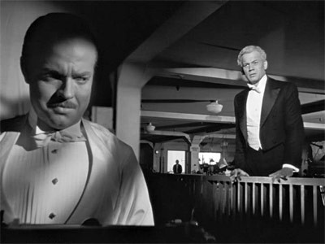
Recall that this was special effects shot. Orsen Welles and Joseph Cotton were not on screen at the same time because of the difficulty in lighting.
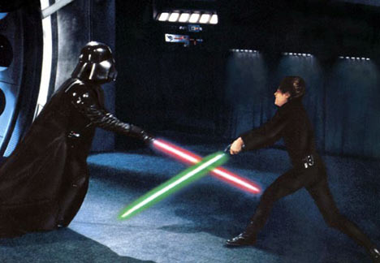

- Low key – heavy shadows, soft transitions from light and dark. Used for film noir. (black cinema). Use of lots of shadows, darker images used to represent moral degradation. Dark streets, smoke.
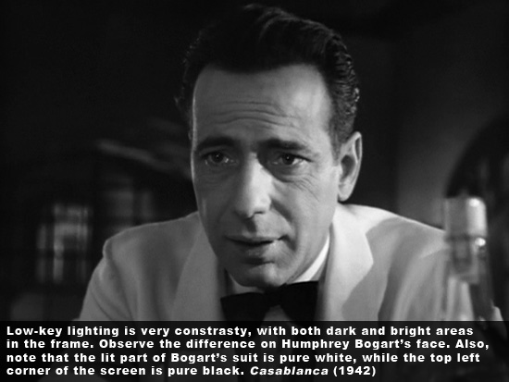

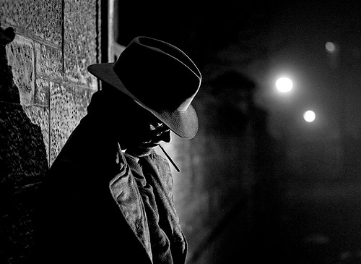

Realist wants to use available lighting. Formalist will use light to paint an image – for example low angle lighting on a face makes the face look sinister. Another example: strong back lighting it gives actors a halo effect.
Gordon Wills – filmed the godfather, used heavy shadow
Three point light scheme. Main light – key light, fill light and the back light.
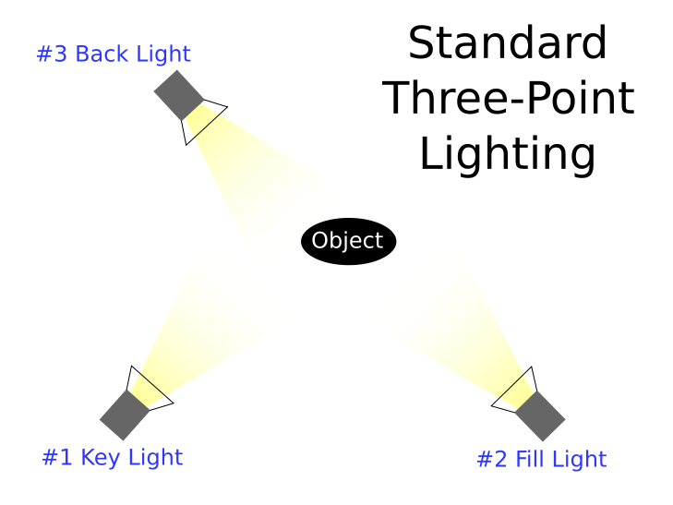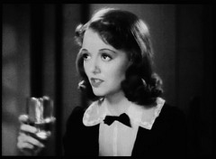

Be aware of dominants – a dominant is the element your eye is attracted first.
Lenses
Normal
Telephoto – long lens. Small depth of field. Anything else will be out of focus. Pulls main action away from background.
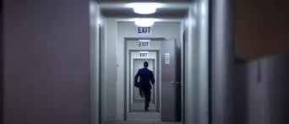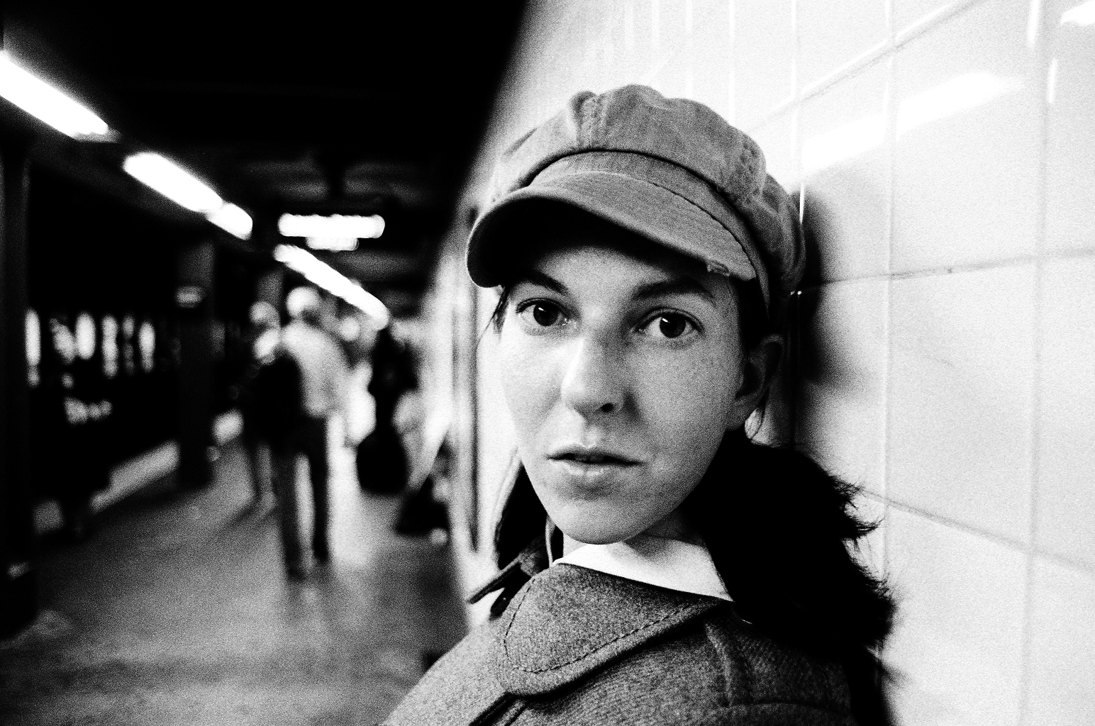

Wide angle
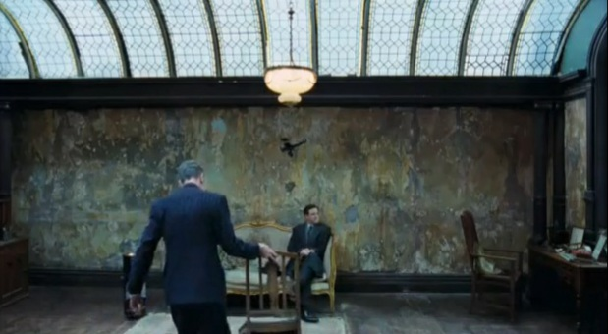
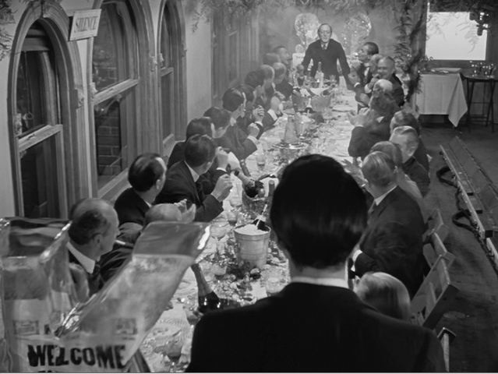

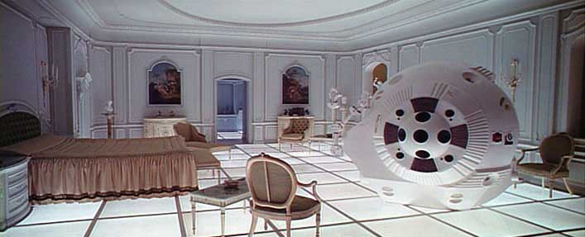
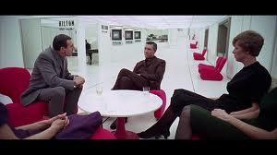
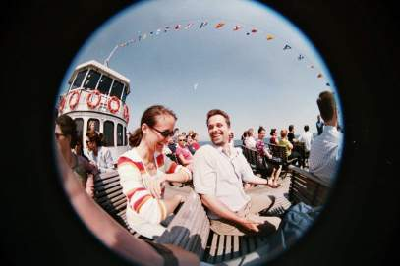

Zoom
Special types of film sequences:
Stop Action Example: Wallace and Gromit (Claymation)
Time lapse
Frozen moment – also known as “bullet time” where an object is viewed from multiple angles. Requires lots of cameras. The black dots in the picture below are all camera lenses.
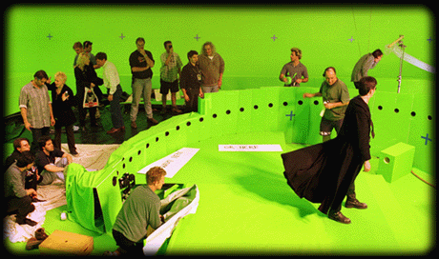
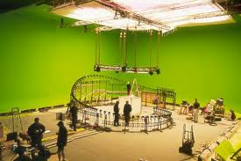

Color
Color did not become common in movies until the 1940´s because it looked very artificial. So color was used for exotic or imaginary places. Example: The Wizard of Oz. The intensity of color contributed to the magical sense of Oz.
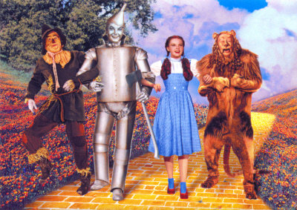
One example of the inaccuracies of this color process is Dorothy’s shirt. On film it appears white; in actuality her shirt was pink.

