IB overview of The Comparative Study
As you can see from that exemplar, the Comparative Study involves you picking an area of film focus — for example, a film theory, a film movement, or a film genre — and 2 films that you want to examine using this focus, and a topic for your study, in other words, a statement of what your comparative study will be about.
And you will deliver this material by way of a recorded multimedia presentation that is no longer than 10 minutes.
An overview of this assessment provided by IB below.
Students carry out research into a chosen area of film focus, identifying and comparing two films from within that area and presenting their discoveries as a recorded multimedia comparative study.
Each student submits the following for assessment.
- A recorded multimedia comparative study (10 minutes maximum).
- A list of all sources used.

ASSESSMENT
Students undertake the following process for assessment.
Inquiry
- Each student carries out broad research, using both primary and secondary sources, in order to investigate possible areas of film focus and films for comparison from within the areas of film focus, using materials from a range of sources, including original films, critiques, publications and other media. Each student decides the selection of the task components, which includes a clearly defined topic for the comparative study. Each student defines the cultural context of the selected films and justifies why these task components were chosen for the comparative study.
- Each student undergoes a process of comparing and contrasting their selected films (and carrying out further focused research into the task components) in order to deepen their understanding of each film.
Action
- Each student assembles their findings, developing a personal and critically reflective perspective, and identifies and gathers appropriate audio-visual material to support the study.
- As a result of the inquiry and action processes outlined above, each student prepares a recorded multimedia comparative study (10 minutes maximum) for submission, ensuring a balance between visual and spoken elements, while making clear reference to their sources as on-screen citations. The primary weight of evidence for the study should be selected from the two chosen films.
Reflection
- Students reflect on the learning undertaken in this task, and review and refine their comparative study ahead of submission.

TASK DETAILS
The comparative study is a recorded multimedia presentation (10 minutes maximum) comprising sound and images. The selection and assembly of the material for submission is an important aspect of the task, and students should ensure that information is communicated clearly, logically and audibly in a visually appropriate manner.
In this task, the examiner is looking for evidence of the extent to which students are able to demonstrate an understanding of the following.
- The task components selected for the study (the area of film focus, two films and the topic), which should include the cultural context of the selected films and a justification of why these components were chosen for the comparative study.
- The links that exist between the selected films, as well as the student’s ability to identify connections, similarities and differences while relating these back to the chosen area of film focus. Students should ensure they give equal weight to both of the films selected for study in their analysis.
- How to effectively construct a comparative study in order to present the work undertaken clearly, logically and in a visually appropriate manner, supporting their work throughout with accurate and appropriate film terminology.
Recorded commentary
The comparative study must contain a recording of the student’s voice throughout, introducing the study and justifying the chosen topic and selected films, as well as providing the commentary for the main body of the work. This voiced commentary may be recorded numerous times until the student is happy with the material. Students may also, if they choose, use a pre-written script (which must be the student’s own work) to be read, recorded and edited into the comparative study. They may also include breaks in their recorded commentary to enable other audio-visual material included in the study to be clearly heard, and likewise should reduce the volume of audio-visual material during the recorded commentary to ensure it is entirely audible.
Please note: The student must not appear on screen at any time in the comparative study.
Use of audio-visual material and copyright
On-screen text, keynote slides, still images, animations, audio recordings and carefully selected and relevant clips from the selected films are all permitted within the comparative study, where appropriate. The primary weight of audio-visual evidence must come from the two chosen films and the student’s recorded voice. While the length of film clips a student can use is not dictated, the clip length should directly match the specific point being made by the student in the recorded commentary.
- Each student must use legal copies of their two chosen films in order to extract the video or audio content for editing into the comparative study. Once the final comparative study has been submitted for assessment to the IB, each student must ensure that the extracted media files are destroyed.
- Students must be aware that their work is solely for academic purposes and that they are not permitted to share or distribute any copyright-protected content used in the comparative study outside of the IB without the express written consent of the copyright holder(s).
- Students are required to clearly reference the two chosen films in the submitted list of sources.
- It is the responsibility of the student to obtain, extract and delete any copyright materials used for this task.
Black slate
The comparative study must begin with a 10-second black slate (included in the total time limit) that clearly states the chosen task components using on-screen text. The student’s recorded commentary, which begins simultaneously with the black slate, should address the justification of these task components.

TASK COMPONENTS
- Area of film focus
- Titles of the two films for comparison
- The chosen topic
Here are examples of black slates for the comparative study.
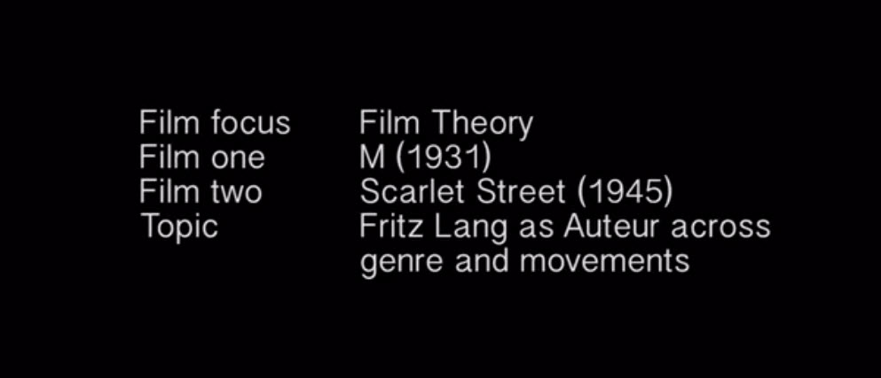
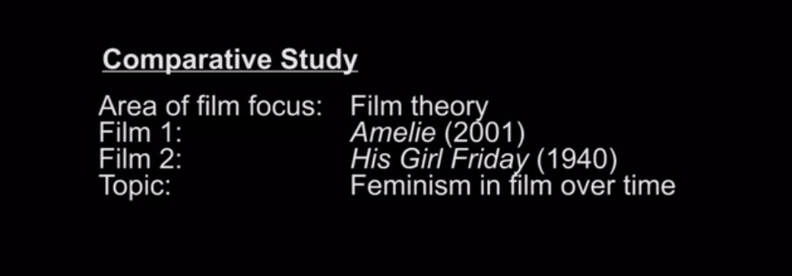

Preparing the work for submission
The comparative study should adopt a formal, academic register and may be delivered in the first person, as appropriate, presenting the student’s personal opinion and perspective as a film student.
The finished comparative study will be submitted online. Students must ensure that their recorded voiceover is clear and audible, and that any text is legible when viewed on screen. Overcrowded or inaudible materials may result in examiners being unable to interpret and understand the intentions of the work, which will result in the examiner being unable to reward the full scope of the work. Where appropriate, students may use subtitles to facilitate understanding.
The comparative study must not be labelled with the student’s name in order to ensure anonymity in the marking process.
Examples of possible task components
The table below outlines some examples of possible task components that students could feasibly consider for this assessment task. These examples are for guidance only and are neither prescriptive not restrictive.

Area of film focus | Film 1 | Film 2 | Topic for comparative study
Film movement: German expressionism | The Cabinet of Dr. Caligari (1920) | Edward Scissorhands (1990) | The representation of social pressure and “the outcast”.
Film movement: French New Wave | Breathless (1960) | Bonnie and Clyde (1967) | The influence of French New Wave on American films.
Film genre and film style: Black comedy | No. 3 (1997) | The Big Lebowski (1998) | The conventions of black comedy.
Film theory: Soviet montage | Battleship Potemkin(1925) | Koyaanisqatsi (1982) | The enduring influence of Eisenstein’s editing techniques.

Academic honesty and on-screen citation
All sources must be acknowledged following the protocol of the referencing style chosen by the school.
- If a student uses work, ideas or images belonging to another person in the comparative study, the student must acknowledge the source as an on-screen citation during the submitted multimedia study, either as a voiced reference as part of the recorded commentary or as on-screen text.
- Students must also submit a separate list of these sources using a standard style of referencing in a consistent manner.
- A student’s failure to appropriately acknowledge a source used in the recorded multimedia comparative study (as outlined in the “Use of audio-visual material and copyright” section), will be investigated by the IB as a potential breach of regulations that may result in a penalty imposed by the IB final award committee.

Terminology
Film focus
For this task, students select an area of film focus that interests and excites them from one of the following.
- Film movements (such as French New Wave, German expressionism, Third Cinema, and so on)
- Film genre and film style (such as film noir, romantic comedy, science fiction, Western, and so on)
- Film theory (such as auteur theory, feminism, Marxist film theory, and so on)
Cultural context
For this assessment task, cultural context involves consideration of some of the following factors, some of which may be blended (such as socio-economic factors).
- Economic
- Geographical
- Historical
- Institutional
- Political
- Social
- Technological
Preparation process
The early stages of this task require students to carry out research into film concepts, theories, practices and ideas that interest and excite them, and that will ensure maximum potential for meeting the needs of the assessment task criteria. From this research, they identify the task components for a recorded multimedia comparative study.
Task components
For this assessment task, each student identifies, selects and researches each of the following task components.
- One area of film focus (from the list above).
- Two films for comparison from within the chosen area of film focus, one of which originates from a contrasting time (historical) or space (geographical) to the personal context of the student, and the other film identified for comparison must arise from a contrasting cultural context to the first film. Students are required to select films they have not previously studied in depth. The selected films cannot come from the prescribed list of film texts provided for the textual analysis assessment task and, once selected, the films cannot be used by the student in any other assessment task for the DP film course or the extended essay.
- A clearly defined topic for a recorded multimedia comparative study, which links both the selected films and the identified area of film focus.
The assessment criteria for this task requires students to provide a strong justification for the choice of task components as part of the recorded multimedia comparative study. This includes the student’s justification for how the films arise from contrasting cultural contexts.

Each student submits the following for assessment
- Each student submits the following for assessment.
- A recorded multimedia comparative study (10 minutes maximum).
- A list of all sources used.

Criteria
Students should be informed that where the submitted materials exceed the maximum time limit for the comparative study, examiners will only assess the work that falls within the prescribed limits. Materials that fall under the minimum time limit are likely to be self-penalising. Submitted work must not contain any appendices as these will not be read by examiners.
External assessment criteria—SL and HL Summary
Comparative study (SL and HL) |  | Marks | Total
A | Task components | 12 | 32
B | Comparing and contrasting | 12
C | Assembling the comparative study | 8

Criteria
A. Task components
Evidence: Recorded multimedia comparative study and sources.
- To what extent does the student demonstrate knowledge and understanding of the components selected for study (the area of film focus, two films and topic)? This should include the cultural context of the selected films and the student’s justification of why these task components were chosen for the comparative study.
- To what extent does the student support their work with a suitable range of relevant sources?
Students who fail to select films from two contrasting cultural contexts will not achieve a mark above 3 in this criteria.
Mark | Descriptor | Possible characteristics
0 | The work does not reach a standard described by the descriptors below.
1–3 | This work is limited.  - The student demonstrates little or no knowledge and understanding of the identified task components. The student lists information relating to the cultural context of the selected films and provides little or no justification for the choice of task components. The work is limited in scope and contains mainly irrelevant or superfluous information.  - The student does not reference sources that are relevant or appropriate to the work. | Basic  Incomplete  Ineffective  Rudimentary  Superficial
4–6 | This work is adequate.  - The student demonstrates some knowledge and understanding of the identified task components. The student outlines the cultural context of the selected films and provides a justification for the choice of task components, but this is underdeveloped. The work is likely to be more descriptive than analytical.  - The student references some sources that are mostly relevant or appropriate to the work, but these are limited. | Acceptable  Reasonable  Standard  Sufficient  Suitable
7–9 | This work is good.  - The student demonstrates a clear and appropriate knowledge and understanding of the identified task components. The student explains the cultural context of the selected films and provides a coherent and logical justification for the choice of task components. The work is accurate and relevant.  - The student references a suitable range of sources that are appropriate and relevant to the work. | Competent  Balanced  Proficient  Relevant  Thoughtful
10–12 | This work is excellent.  - The student demonstrates an effective and highly appropriate knowledge and understanding of the identified task components. The student analyses the cultural context of the selected films and provides a credible and persuasive justification for the choice of task components. The work is detailed, accurate and relevant.  - The student references an effective range of sources that are highly appropriate, adding to the critical perspectives explored in the work. | Compelling  Honed  Insightful  Mature  Sophisticated

B. Comparing and contrasting
Evidence: Recorded multimedia comparative study and sources.
- To what extent does the student compare and contrast the selected films, making links to the chosen topic?
- To what extent does the student provide an equal treatment of the two films selected for study?
Mark | Descriptor | Possible characteristics
0 | The work does not reach a standard described by the descriptors below.
1–3 | This work is limited.  - The student lists ways in which the two films connect to each other and to the chosen topic, making superficial observations regarding similarities and differences that are inaccurate, irrelevant or incoherent.  - The student focuses on one film in particular throughout the comparative study. | Basic  Incomplete  Ineffective  Rudimentary  Superficial
4–6 | This work is adequate.  - The student adequately outlines how the two films connect to each other and to the chosen topic, making accurate observations regarding similarities and differences, but this work is underdeveloped.  - The student generally gives more consideration to one of the films in particular during the comparative study. | Acceptable  Reasonable  Standard  Sufficient  Suitable
7–9 | This work is good.  - The student successfully explains how the two films connect to each other and to the chosen topic, making accurate and relevant observations regarding similarities and differences.  - The student gives fairly balanced consideration to the two films throughout the comparative study. | Competent  Balanced  Proficient  Relevant  Thoughtful
10–12 | This work is excellent.  - The student effectively analyses how the two films connect to each other and to the chosen topic, providing insightful, accurate and relevant observations regarding similarities and differences.  - The student gives equal consideration to the two films throughout the comparative study. | Compelling  Honed  Insightful  Mature  Sophisticated

C. Assembling the comparative study
Evidence: Recorded multimedia comparative study and sources.
- To what extent does the student assemble the comparative study in a clear, logical, audible and visually appropriate manner?
- To what extent does the student support the work with accurate subject-specific terminology?
Mark | Descriptor | Possible characteristics
0 | The work does not reach a standard described by the descriptors below.
1–2 | This work is limited.  - The comparative study is constructed with little or no consideration of how to logically convey information. The work is limited, both in terms of audibility and supporting visuals.  - The work contains little or no accurate subject-specific terminology. | Basic  Incomplete  Ineffective  Rudimentary  Superficial
3–4 | This work is adequate.  - The comparative study has been constructed with some attempt to logically convey information. It is audible and makes adequate use of supporting visuals.  - The work contains some accurate subject-specific terminology, but this is underdeveloped. | Acceptable  Reasonable  Standard  Sufficient  Suitable
5–6 | This work is good.  - The comparative study has been assembled to follow a clear and coherent structure. It conveys information audibly and with supporting visuals and examples that are mostly appropriate and meaningful, with some clear links to the topic being discussed.  - The work is well supported with appropriate and accurate subject-specific terminology. | Competent  Balanced  Proficient  Relevant  Thoughtful
7–8 | This work is excellent.  - The comparative study is logical and effectively organized, conveying information audibly and in a visually appropriate manner. It is substantiated by relevant and meaningful visuals and examples that are effectively and explicitly linked to the topic being discussed.  - The work is consistently and effectively supported with accurate subject-specific terminology. | Compelling  Honed  Insightful  Mature  Sophisticated

