Preparing for the Comparative Study—Digging Deep
Watch this Comparative Study Example: https://player.vimeo.com/video/190571855

As you can see, in this Comparative Study example, the student picked the following task components.
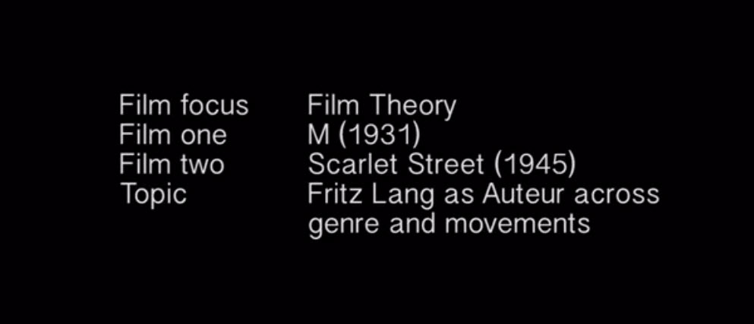
Therefore, it is very important that you understand the role of each of these components in film analysis, and that you thoroughly review each of these components BEFORE you start work on your actual Comparative Study.
So, starting now and over the upcoming lessons, you will be completing a few assignments on film movement, film genre, and film theory
These are the only areas of focus you can choose from, and you need to get to know very well in order to get a good score.
We will focus in particular on what is meant by cultural context of a film, which you have already explored for your Textual Analysis, and which you will now apply to the Comparative Study.
Once you have begun work on your Comparative Study, in an upcoming lesson, we will return to this exemplar and two others, and you will have the opportunity to examine them further and score them according to the grading rubric.

Comparative Study Schedule
To help prepare you for the Comparative Study, and to give you the time you will need to write and produce it, you will be asked to follow the schedule below.
(For schools following the Pamoja calendar, these activities run over 10 weeks, starting in week 48, and finish in week 57. Other schools will schedule these lessons according to their own timetable, or as instructed by the teacher).
You have to choose your task components, research your films, and write and produce a 10-minute multi-media presentation within the first few lessons.
Teachers will then provide you with feedback and meet with you in Live Lessons to discuss your progress and answer any questions you might have.
After that, you will pull together a Final Presentation.
You will be very busy during these lessons, and you will have to plan accordingly.
Lesson - The Comparative Study
- Introduction to The Comparative Study
Lesson - Preparing for the Comparative Study - Digging deep
- Work on film movements
- Activity submission - So many movements
Lesson - Comparative Study - A genealogy of genre
- Work on film genre
- Activity submission - Genre DNA table
Lesson - Comparative Study - Adopt a theorist
- Work on film theory
- Activity submission - Talking the talk
Lesson - Comparative Study - Making connections
- Work on film topic
- Activity submission - Film school thesis
Lesson - Comparative Study - Declaration of films
- Activity submission - Declaration of film components - film focus, 2 films, and film topic
Lesson - Comparative Study - Research
- Activity submission - Bibliography
Lesson - Comparative Study - Writing the Documentary
- Activity submission - Script outline / source
Lesson - Comparative Study - Producing your vision
Lesson - Comparative Study - The finish line
- Activity submission - Final presentation

A very good idea
Although you will be working on short assignments, it is a very good idea for you to start thinking about what you are going to write about for your Comparative Study NOW.
This means that you should start thinking about what film focus, 2 films, and topic you would like to explore.
While we will be going over all this material in detail in an upcoming lesson, don’t forget that all material related to this assessment can also be accessed on the IB Film Studies Portfolio Website.
Review - IB Film Studies Portfolio Website
When you do start working on your Comparative Study, Pamoja students will only have three weeks to take it from first draft to produced presentation, and then only a week to react to teacher feedback, so any work you start doing now will really be helpful.
For schools that do not follow the Pamoja timetable, your teacher will work with you to organise your schedule.

Jonas Mekas
To me, cinema is one big tree, with many branches.
Jonas Mekas
Along with many other international archivist pioneers, such as Henri Langlois, Jonas Mekas spent his entire professional career searching out and preserving the lost, endangered and forgotten works of global cinema.
Thanks to their efforts, film students and scholars now have access to a wider and more diverse range of resources than at any other time in the medium’s history.
How to organise this wealth of materials is an ongoing challenge for film students. One way to provide order to the overwhelming amount of films, television series, short works, online media, and so on, is to group similar texts together.
Film scholars often link films by their points of origin in time or location, by their expressed subject matter or manner of filming, by the expressed aims or objectives of individual filmmakers, and even by the conceptual implications that particular films might hold for different theoretical methods or schools.
The Film Guide refers to such frameworks and groupings as a film focus and asks teachers and students to consider how film’s overall global significance over the past 140-odd years can be productively explored by adopting such a focus, while directly linking it to specific cultural contexts.
For instance, a movement is a name given to a collection of films that are grouped together by virtue of the distinct convergence of their geography, time period and filmmaking style or method of production.
Film history is replete with several well-known and widely encountered movements: German expressionism, Italian neo-realism and the French New Wave are prominent examples and serve as touchstones for many students seeking to understand both film history and its impact on the society and culture.
But there are many, many movements—some with equally famous names, some whose names are only just now emerging.
But how do we know which film movement should be considered worthy of research and investigation?
The only way to know is to jump right in and start digging deep.

So Many Movements
Begin by downloading the list of film movements, then think about how each movement emerged from a particular geographical region, time period, and unique approach to a film style and/or genre.
Download - 18 Important Film Movements Every Movie Buff Should Know
Then, consider the cultural aspects of a film movement.
For instance, in Year 1, the lessons on German Expressionism introduced some of the political, economic, social and cultural conditions of interwar Germany during the years 1919 - 1933, as well as some of the distinct techniques used by key German expressionist directors such as Fritz Lang, Robert Wiene and FW Murnau.

ASSIGNMENT GUIDELINES
Using the template provided, discover and explore two film movements that are associated with either a contrasting geographical region or time period (or both).
Then, using classroom, school-based, and online resources, gather enough information about each film movement so that you can:
- Identify the film movement
- Provide an explicit justification for your choice of each film movement
- Identify three defining characteristics associated with this movement
- List three directors and their films associated with this movement
- Identify at least three of the cultural contexts that gave rise to, or influenced, this movement
- Provide an image that is representative of this film movement (this could be scene still, actor photo, or any other image of your choosing) and a brief rationale explaining why this image is representative.
Download - So Many Movements template (MS Word format)
Download - So Many Movements template (PDF format)

