IB Extended Essay Lesson #6—Assessment

In this lesson you will learn about how this piece of work will be assessed. However, to start with it is worth considering the objectives of the assessment. Read through this fictional dialogue between a student and supervisor to find out more regarding EE assessment:

Student A: I’ve learned a lot of about the expectations of the Extended Essay process but I have no idea how it is marked.
Supervisor Z: Hmm…That’s not as simple a question as you might think. However, I will give you the basics.
A: So what is the most important thing?
Z: Well from your perspective; that the extended essay, in conjunction with your Theory of Knowledge, is worth up to three points for your diploma.
A: So how do I get three points?
Z: Your Extended Essay and Theory of Knowledge are both graded from A to E and the combination of these produces the number of bonus points. The precise combinations are shown in a matrix. You need to do well in both to get three points.
A: So can I lose points?
Z: No. A few combinations give you no points. The thing to be aware of is if you get an E. This will cause you to fail your whole diploma.
A: That’s pretty harsh.
Z: The IB want you take it seriously. However, provided you are prepared to work and listen to advice it will not be a problem.
A: Don’t worry, I am serious about this and really interested in my topic.
Z: That’s good to know.
A: However, I am still a bit confused. I thought you got a mark for the extended essay, not a letter grade.
Z: In fact you get both. The extended essay is a given a numerical mark by your examiner. Your essay is then given a letter grade based on this mark.
A: How does that work?
Z: Your essay is marked using criteria. There are five criteria. Each of the criteria is worth number of marks and the total is 34.
A: What are the criteria?
Z: They are focus and method, knowledge and understanding, critical thinking, formal presentation and finally engagement.
A: And how do I know how many marks I will get for each criteria?
Z: Again that is something you will be given as you get further into the process.
A: And these criteria you talked about – they are the same for every extended essay, regardless of subject?
Z: Yes they are. There is further information provided by the IB about how they are applied in different subjects, but your supervisor will share this with you later.
A: So how do I convert my total mark into my letter grade?
Z: That’s a simple one – you cannot.
A: What do you mean?
Z: The senior examiners decide which marks equate to which letter grades, but that is not done until after your essay has been marked.
A: You mean they do each essay individually?
Z: No. The senior examiners get together and from all the marking they have seen they decide where the grade boundaries are set. So, for example if the boundary between a D and a C is set at 13 to 14 marks and the boundary between a C and a B is set at 21 to 22, then any mark between 14 and 21 inclusive would give you a C.
A: And then we use the matrix to combine this C with my ToK grade to give me a number of points.
Z: That is correct!
A: Got it! Thank you so much for explaining!
Z: No problem. Don’t forget you’ll get more information during this lesson, and you will get further detail when you choose your topic.

Assessment objectives and criteria
Start by having a look at the assessment objectives for the Extended Essay, set by the IB. Each objective provides information about how the Extended Essay will be assessed.

Knowledge and understanding
- To demonstrate knowledge and understanding of the topic chosen and the research question posed.
- To demonstrate knowledge and understanding of subject specific terminology and/or concepts.
- To demonstrate knowledge and understanding of relevant and/or appropriate research sources and/or methods used to gather information.

Application and analysis
- To select and apply research that is relevant and appropriate to the research question.
- To analyse the research effectively and focus on the research question.

Synthesis and evaluation
- To be able to discuss the research in terms of a clear and coherent reasoned argument in relation to the research question.
- To be able to critically evaluate the arguments presented in the essay.
- To be able to reflect on and evaluate the research process.

A variety of (research) skills
- To be able to present information in an appropriate academic format.
- To understand and demonstrate academic integrity.
A: Focus and Method | B: Knowledge and Understanding | C: Critical Thinking | D: Formal Presentation | E: Engagement
Topic  Research question  Methodology | Context  Subject specific terminology and concepts | Research  Analysis  Discussion and evaluation | Structure  Layout | Process  Research focus
6 Marks | 6 Marks | 12 Marks | 4 Marks | 6 Marks
- These objectives are realised by creating a set of criteria against which you are marked. In the extended essay there are five of them each with a different mark allocation. The total mark for the extended essay is 34. An overview of the criteria is shown below:

So what does this mean? Select each of the criteria to see a description.

A: Focus and method
This criterion focuses on the topic, the research question and the methodology. It assesses the explanation of the focus of the research (this includes the topic and the research question), how the research will be undertaken, and how the focus is maintained throughout the essay.

B: Knowledge and understanding
This criterion assesses the extent to which the research relates to the subject area/discipline used to explore the research question, or in the case of the world studies extended essay, the issue addressed and the two disciplinary perspectives applied, and additionally the way in which this knowledge and understanding is demonstrated through the use of appropriate terminology and concepts.

C: Critical thinking
This criterion assesses the extent to which critical-thinking skills have been used to analyse and evaluate the research undertaken.

D: Presentation
This criterion assesses the extent to which the presentation follows the standard format expected for academic writing and the extent to which this aids effective communication

E: Engagement
This criterion assesses the student’s engagement with their research focus and the research process. It will be applied by the examiner at the end of the assessment of the essay, and is based solely on the candidate’s reflections as detailed on the Reflections on Planning and Progress Form (RPPF), with the supervisory comments and extended essay itself as context.

There are specific descriptors for each of the marks within each criteria and then further guidance on how these work in specific subject areas. However, this should not be your major concern at the moment. You will learn more about the descriptors when you actually start the process and your supervisor will discuss the subject specific requirements with you.

The IB Diploma EE-TOK matrix
Finally you need to understand how the mark you gain from the extended essay transforms into points for your overall diploma. This happens in conjunction with your ToK grade. In the extended essay the mark you gain out of 34 is converted into a letter grade from A to E. The boundaries for the conversion of a marks total to a letter grade are determined by the senior examiners and are not known in advance. For example if the boundary for A and B is set at 29/30, then a mark of 28 would be a B and a mark of 32 an A. The same happens for ToK. Hence you will end up with a letter grade for both ToK and extended essay and the combination of these determines whether you are awarded 3, 2, 1 or 0 points. Note that an E in either ToK or extended essay is an automatic failing condition. How these combinations equate to points in shown in the matrix below. 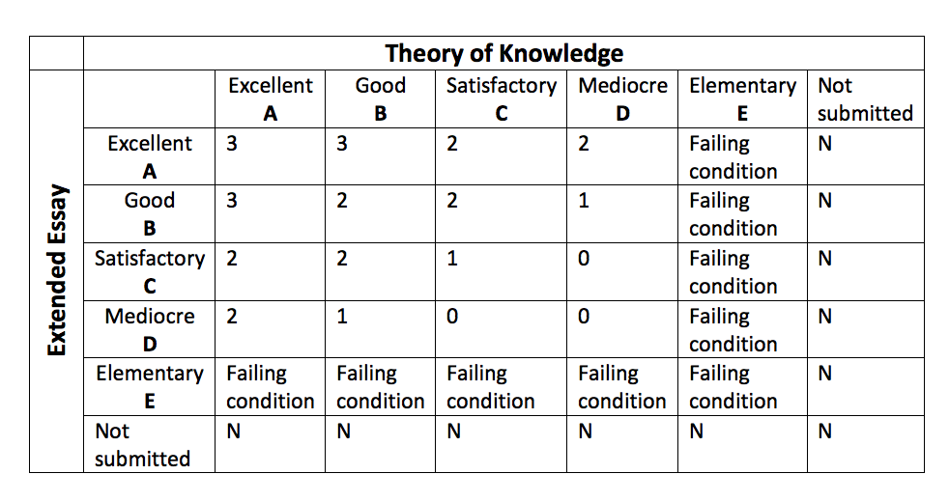

TASK: Reflection: Assessment Methods
It will be a number of weeks yet before you have to start worrying about the details of the final marking process and this is something you will be guided through by your supervisor. However you may have some reflections or questions on what you have learned this lesson. Post these on the assessment process in your Journal here so that your supervisor can respond to these.
(Note: This assignment is not graded - it will be reviewed by your supervisor during your writing process and for the viva voce.)

