Extended Essay Scoring Rubric

Assessment Overview

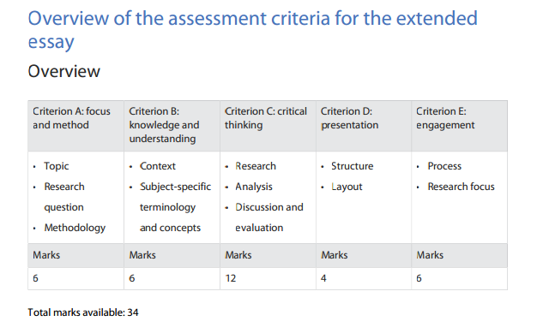
For each criterion mark the level score according to each descriptor.
When finished reviewing the EE, total up the level scores for each criterion. This will provide you with a total marks score. Place the student score over the total marks available (34).

The Assessment Scoresheet is located at the end of this document.

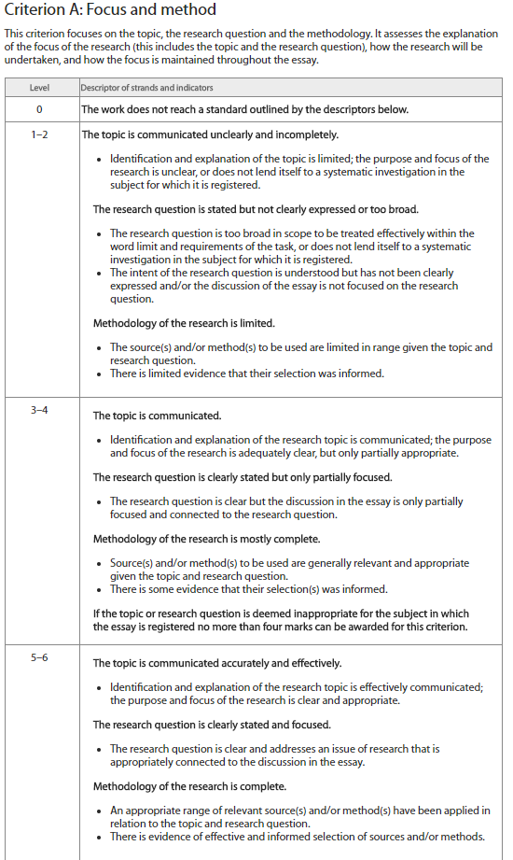
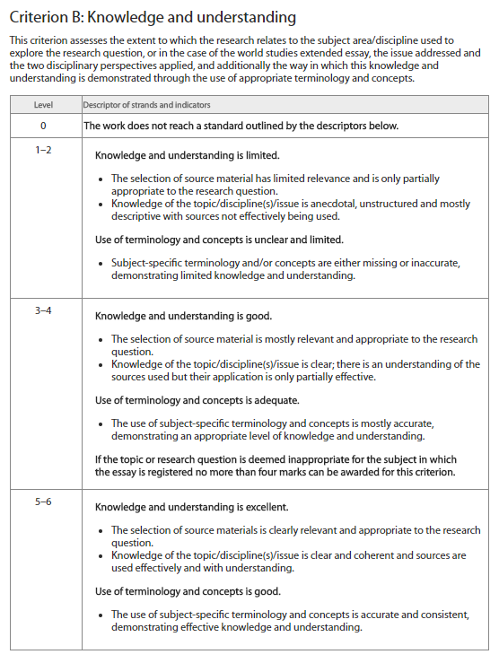

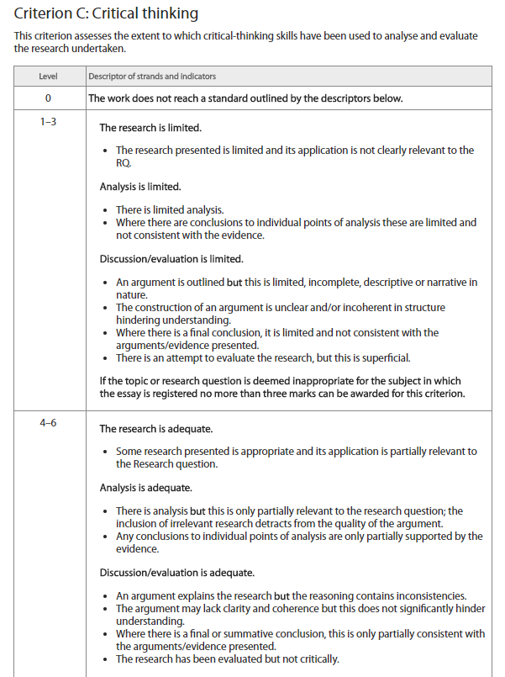

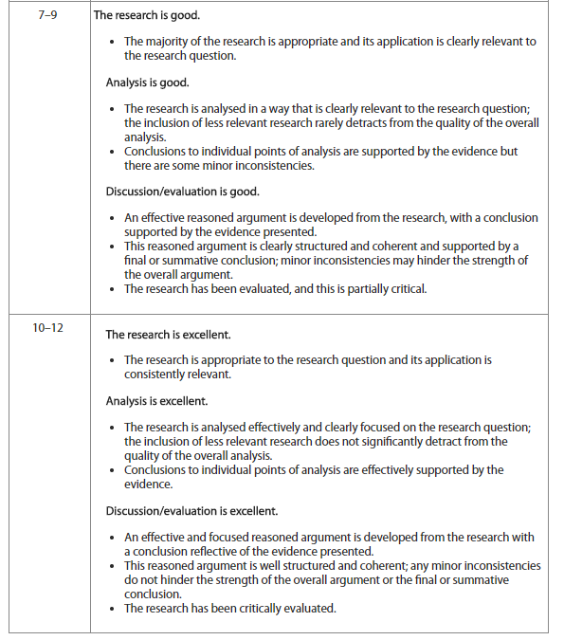

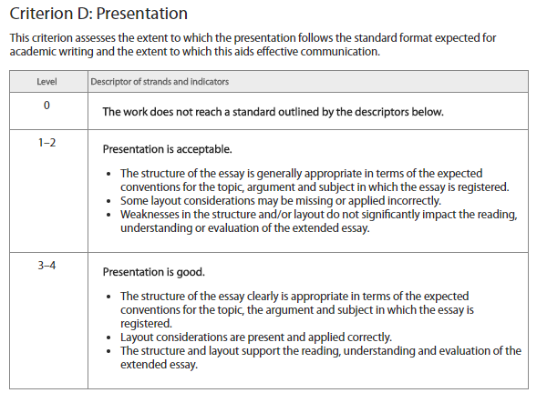
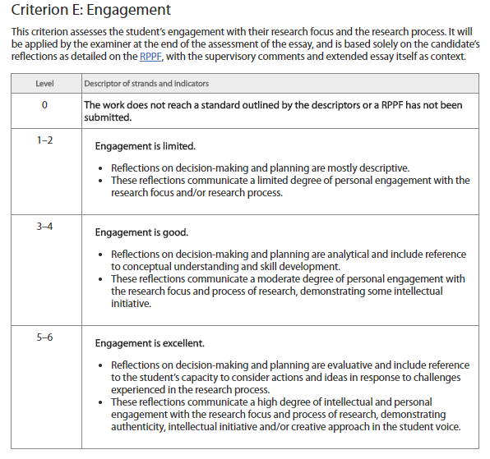

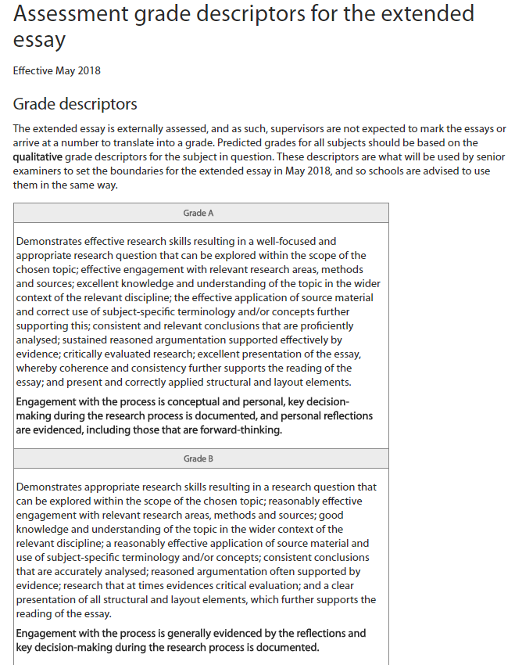

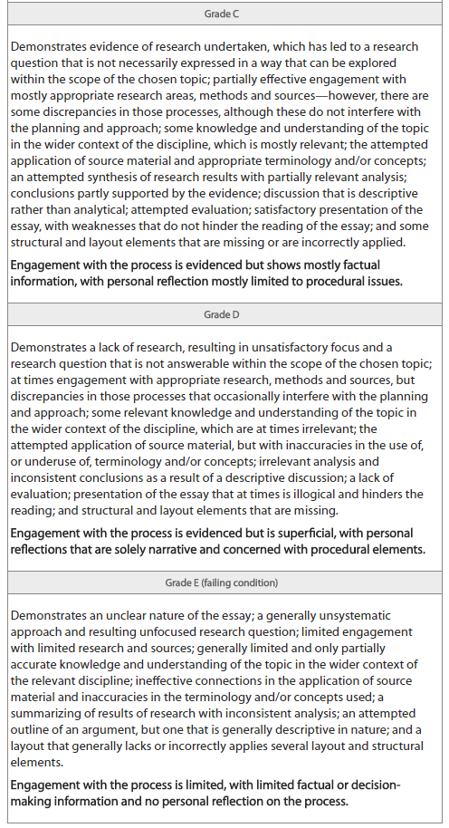
Assessment Scoresheet:

Total Score (out of 34): /34

Assessment Grade (A-E):

Additional Notes:

