IB Film, Year Two
Film Portfolio Assessment: Authenticity Statement

In order to ensure that your work is original and fully authentic, you will be required to add the following content to your Film Portfolio Assessment (FPA) Pages documentation.
Students will add the statement below to the bottom of the Table of Contents section of the FPA. Please refer to the FPA template to see what the TOC page looks like, and place this statement at the bottom of that page:
Pages Authenticity Statement:
I confirm that all contents within this assessment piece are original and does not include any audio-visual material that was created by anyone other than myself or my fellow student collaborators unless cited otherwise.
I consent to the examination of this assessment piece.
In addition to the Pages document, students will need to start the FPA Reel video with an opening title card that contains the following content using a Black Title Card with White Text:
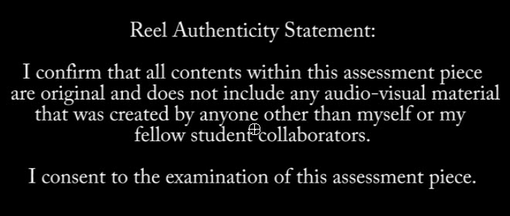
Students will also be required to read and record their voice reciting the statement and then add the recording to the audio track that will play while the tile card displays the text. This officially declares that your work is authentic, and student created. Any violations may result in a chapter score of 0/8 or full invalidation.
The slate and recording should not last more than 15 seconds in length. This time will not be included in the overall duration time for the FPA Reel. That time will start after the opening slate slide ends.
The opening slate, as covered in the course content, will follow the Authenticity Statement slide 15 seconds into the full FPA Reel video.
If you have any questions, please contact your teacher to seek clarification on this required task.

